Working with Live Paint in Illustrator CS3
http://www.trainstation.cc/Tutorials/Illustrator/live-paint.html
(beginner to intermediate level)
In Illustrator CS2 Adobe introduced the Live Paint feature which revolutionized how a designer or artist could add colour to a drawing. In Illustrator CS3 an additional refinement allows you to easily choose colors from the swatches palette without moving your mouse away from your drawing. The Live Paint feature allows the artist to flow paint into areas created by the intersection of shapes and paths much like a paint bucket tool would work in a raster program. This is a vast improvement over having to individually create each distinct shape in a drawing.

Step 1: Create a simple drawing
In this step create a drawing starting with a simple shape such as a elipse and using the pencil tool and other shapes to create some intersecting areas. Don't worry if your lines stick out beyond the edge of the shape's border or cross each other- we can fix that. 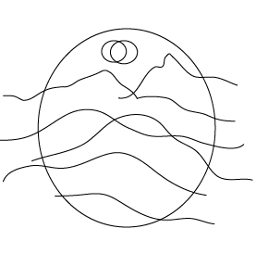

Step 2: Making a Live Paint group
Select all of the parts of your drawing. The easiest way to do this is to take the Selection Tool (black arrow) and marquee drag over the entire drawing to select it all.
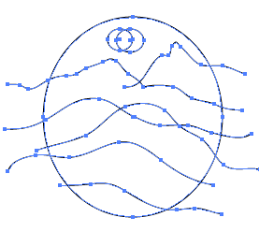
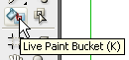
Then select the Live Paint bucket from the Toolbox and move it over your selected drawing. The paths in your drawing will turn red and you will see a tool tip that says "Click to make a Live Paint group". Go ahead and click once on your drawing.
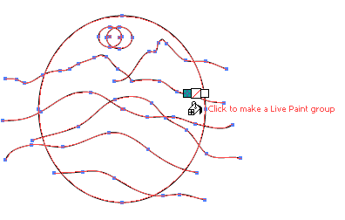

Step 3: Fill areas with colour
Once you have created a Live Paint group you can use the Live Paint paintbucket to fill the various areas created by the intersection of paths and shapes (known as faces in a Live paint group) with colour.
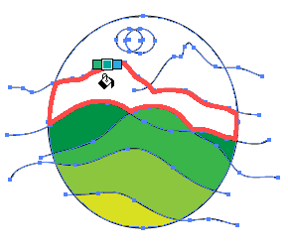
Tip: The three square boxes above the paintbucket cursor reference colours in the swatches palette. The middle box represents the currently selected colour and the other boxes, the previous and next swatches in the Swatches palette. You can choose the next or previous swatch by using your right or left arrow keys. Note: This colour selection feature is new in Illustrator CS3.
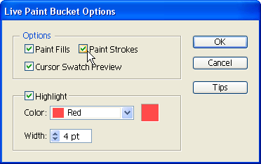
Tip: You can also stroke path sections (known as edges in Live Paint) by setting the Live Paint tool to paint paths. To set the tool - double click the Live Paint bucket in the Toolbox and make sure both the Paint Fills and Paint Strokes is selected.
Then set your stroke attributes such as colour and size. Now when you mouse over the paths in your Live Paint group your cursor will change to a paintbrush.
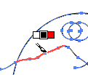

Step 4: Removing unneeded lines
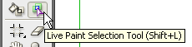
Choose the Live Paint Selection tool found to the right of the Live Paint Bucket in the Toolbox. Click on an uneeded line such as ones that extend beyond the eliptical shape that borders my demo drawing and click the delete key on the keyboard.
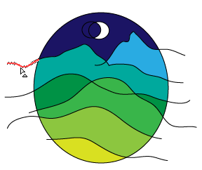
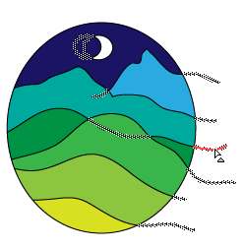
Tip: You can select multiple edges or faces by clicking the first edge or face and shift-clicking to select the remaining edges or faces you want.

Step 5: Adding more lines (optional)
What if - after doing all this work your realize your drawing needs another another line or area? First draw another line over your existing drawing.
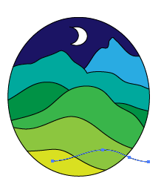

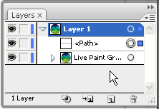
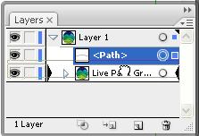
You will find that the Live Paint Bucket does not react to your new line - don't worry. This is because it is not yet part of your Live Paint Group.
If you look in your Layers palette you will see that all your paths and shapes have been collected into a specialized Live Paint Group but your new line is still floating loose in Layer 1.
Simply select the path in the Layers palette and drag it onto the Live Paint Group in the Layers Palette. You will see two large black triangles and you move the path layer over the Live Paint group layer and when you do let go of the mouse. Now your Live Paint Bucket will react to the shape created by the insection of this new paths with the other shapes in the drawing and you can fill it like you did with the other. Once you have added the colour use the Live Paint Selection tool to delete and unneeded lines.
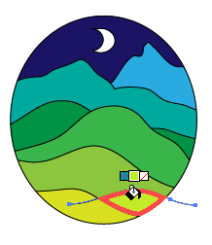
© TrainStation - an Adobe Authorized Training Provider
all rights reserved
Author - Leslie R. Williams

You could use this idea to make a series of cards for various themes:

